PROJECT STATEMENT 1

- Virtual private network
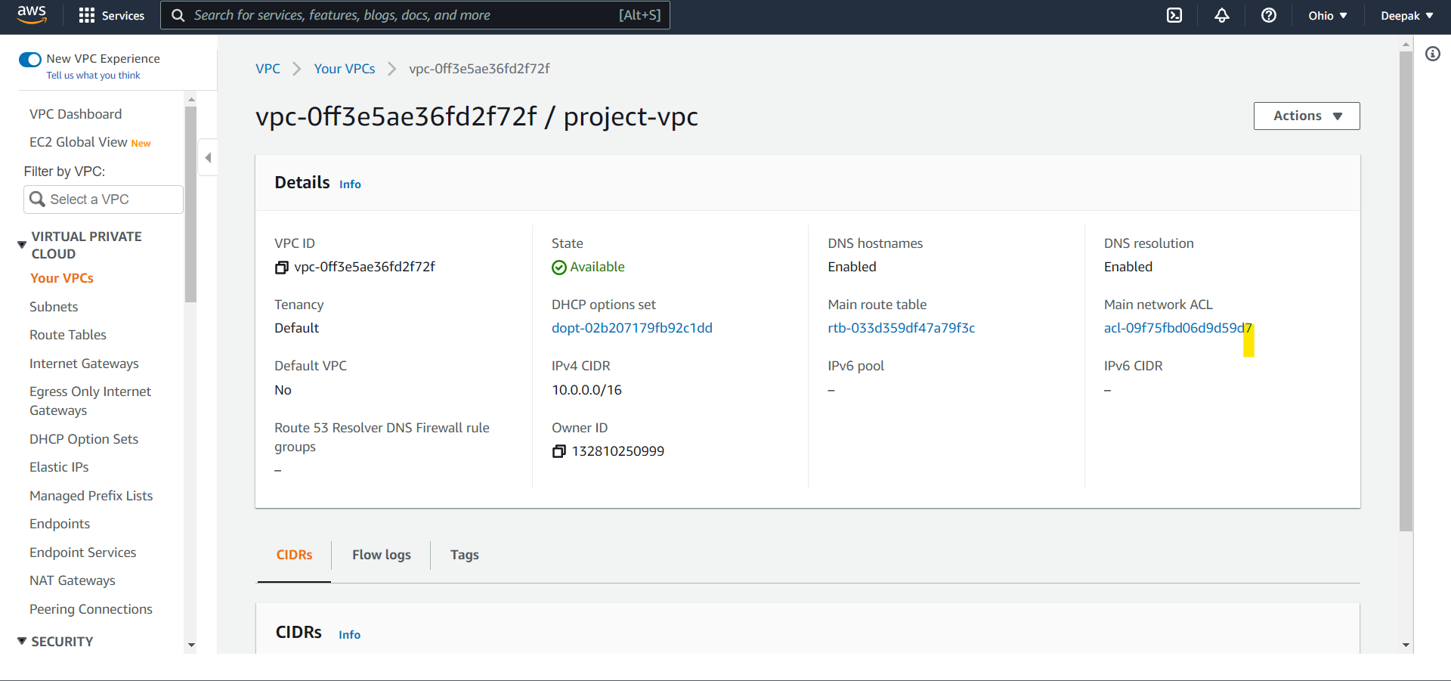

- Public subnets and private subnets created in Multi-AZ
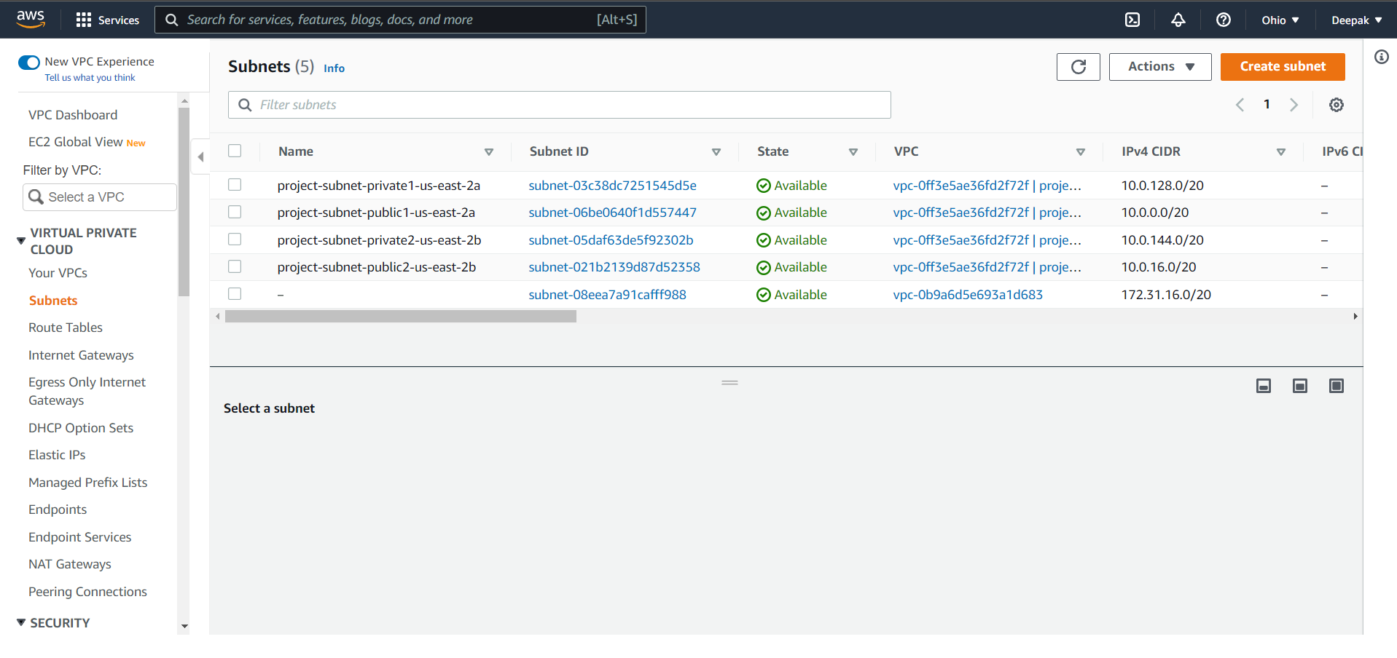

- Public subnets are associated with public route tables and internet gateway
- Private subnets are associated with route tables and NAT gateway
- Front end web application is deployed in a public subnet where users can access the data
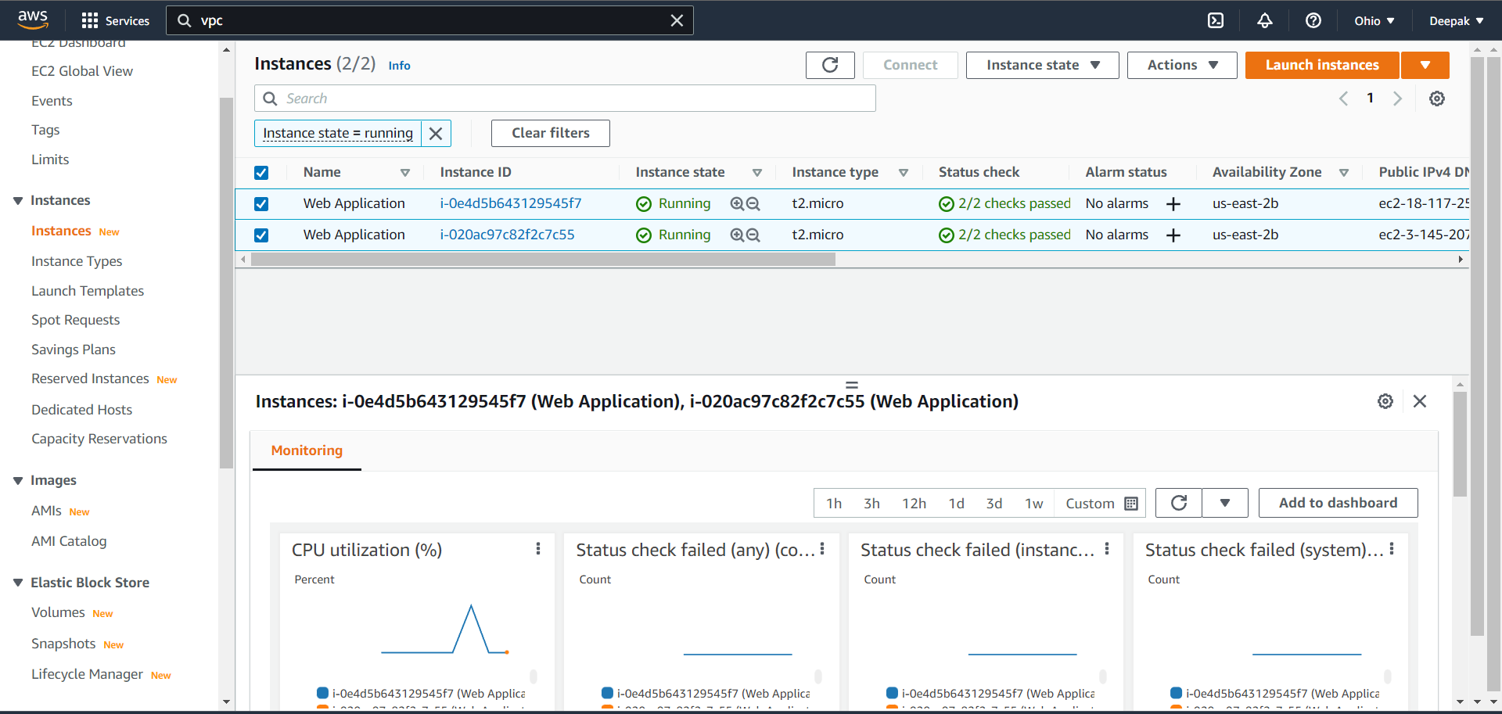
- The database server will be at the backend without public access (set to be private)
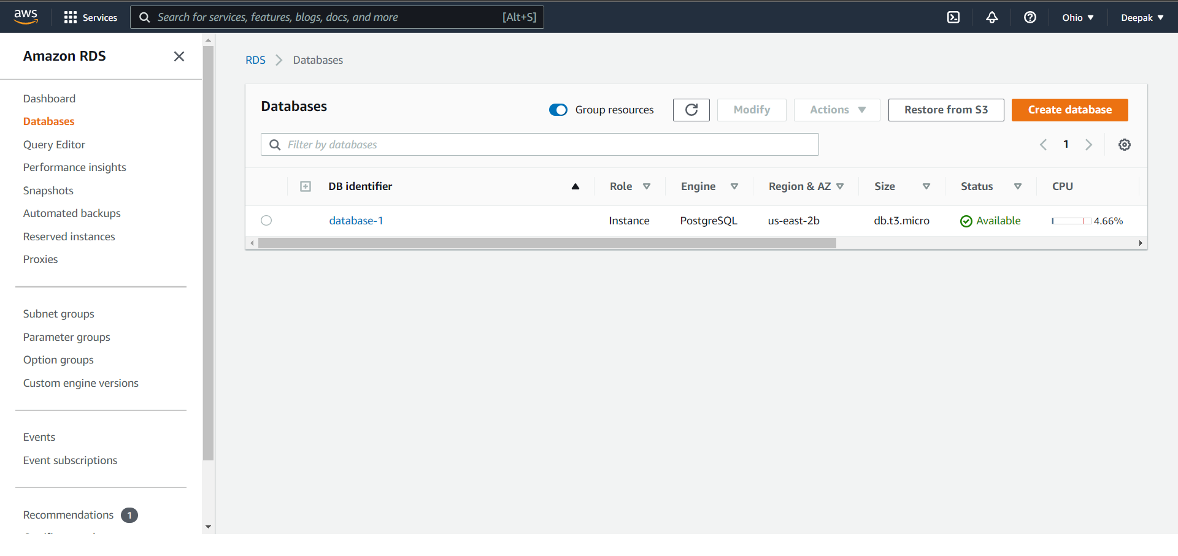

- A backup plan must be created to avoid loss of data due to any disaster or accidental data loss

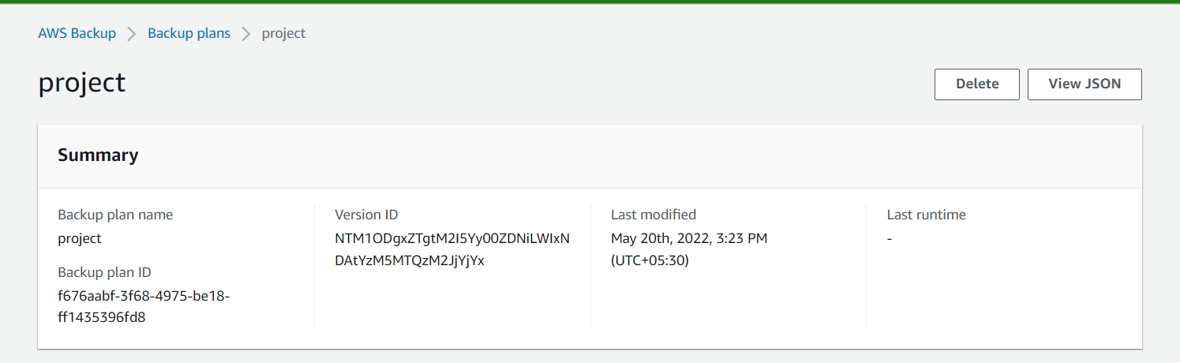
- A backup rule should be created based on production requirement
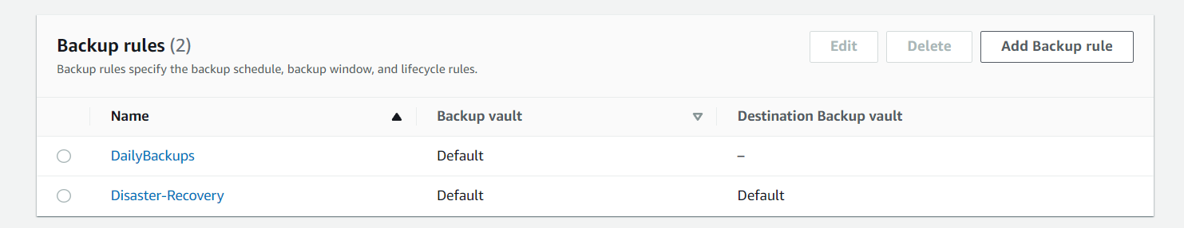

- Resource assignment should be created and add the required resources for backup

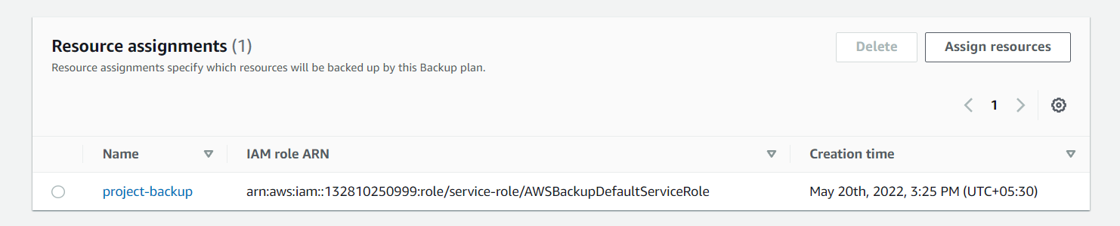

- And created an autoscaling group to burst into 4 instances when there is high utilization

